PRACTICAL: 3

# AIM:

Footprinting is the process of accumulating data regarding a specific network environment, usually for the purpose of finding ways to intrude into the environment. Footprinting can reveal system vulnerabilities and improve the ease with which they can be exploited. It is also known as reconnaissance. Study practical approach to implement Footprinting: Gathering Target Information making use of following tools:

Dmitry – Deepmagic UA Tester

Whatweb

# THEORY:

**DMITRY**: DMitry (Deepmagic Information Gathering Tool) is an open-source Linux CLI tool developed by James Greig. Coded in C. DMitry is a powerful information gathering tool that aims to gather as much information about a host that is possible. Features include subdomains search, email addresses, uptime information, system & server data, TCP port scan, whois info lookup, DMitry is a modular program that allows user-specified modules. DMitry is easy to use and removes the need to enter multiple commands. DMitry is preinstalled in Kali Linux,if you are using another distribution of Linux that does not come with DMitry preinstalled but you can install DMitry from the source. Dmitry is part of a subset of information gathering tools included in Kali Linux. The purpose of these tools is to help attackers identify information about a target, to assist with locating potential attack vectors that may work on the system.

**UA-Tester**: UA-Tester is designed to automatically check a given URL using a list of standard and non-standard User Agent strings and provides us valuable information for how websites respond to certain browsers, bots or tools.This tool is written in Python by Chris John Riley. It also tries various options like setting cookie, redirection, URL-stability(whether the URL expires or not) an a lot more. Now I am not sure of how this might be used as a WAF-Tester. But I think, all these options & tests you perform resemble a Nmap scan.

**WHATWEB**: With WhatWeb you can get the details of any website, which plugin is being used, what is their version, which cms are being used here or which website is being used by the platform, which web framework should be used on the website, What security is being used here, the website’s email address, account id, etc.

With the WhatWeb tool, you can also easily scan your local network whether any website or webserver is running there or not, this tool is made in Ruby language, which has more than 1800 plugins to manage the website. Uses that can extract a lot of useful information from a website.

Most WhatWeb plugins are thorough and recognise a range of cues from subtle to obvious. For example, most WordPress websites can be identified by the meta HTML tag, e.g. ”, but a minority of WordPress websites remove this identifying tag but this does not thwart WhatWeb. The WordPress WhatWeb plugin has over 15 tests, which include checking the favicon, default installation files, login pages, and checking for “/wp-content/” within relative links.

# CODE:

**Dmitry:**

dmitry -winsepo 19IT016_dmitry.txt flipkart.com

**UA-Tester: Whatweb:**

Whatweb -v [amazon.com](http://www.Facebook.com/)

**OUTPUT:**

## Dmitry:

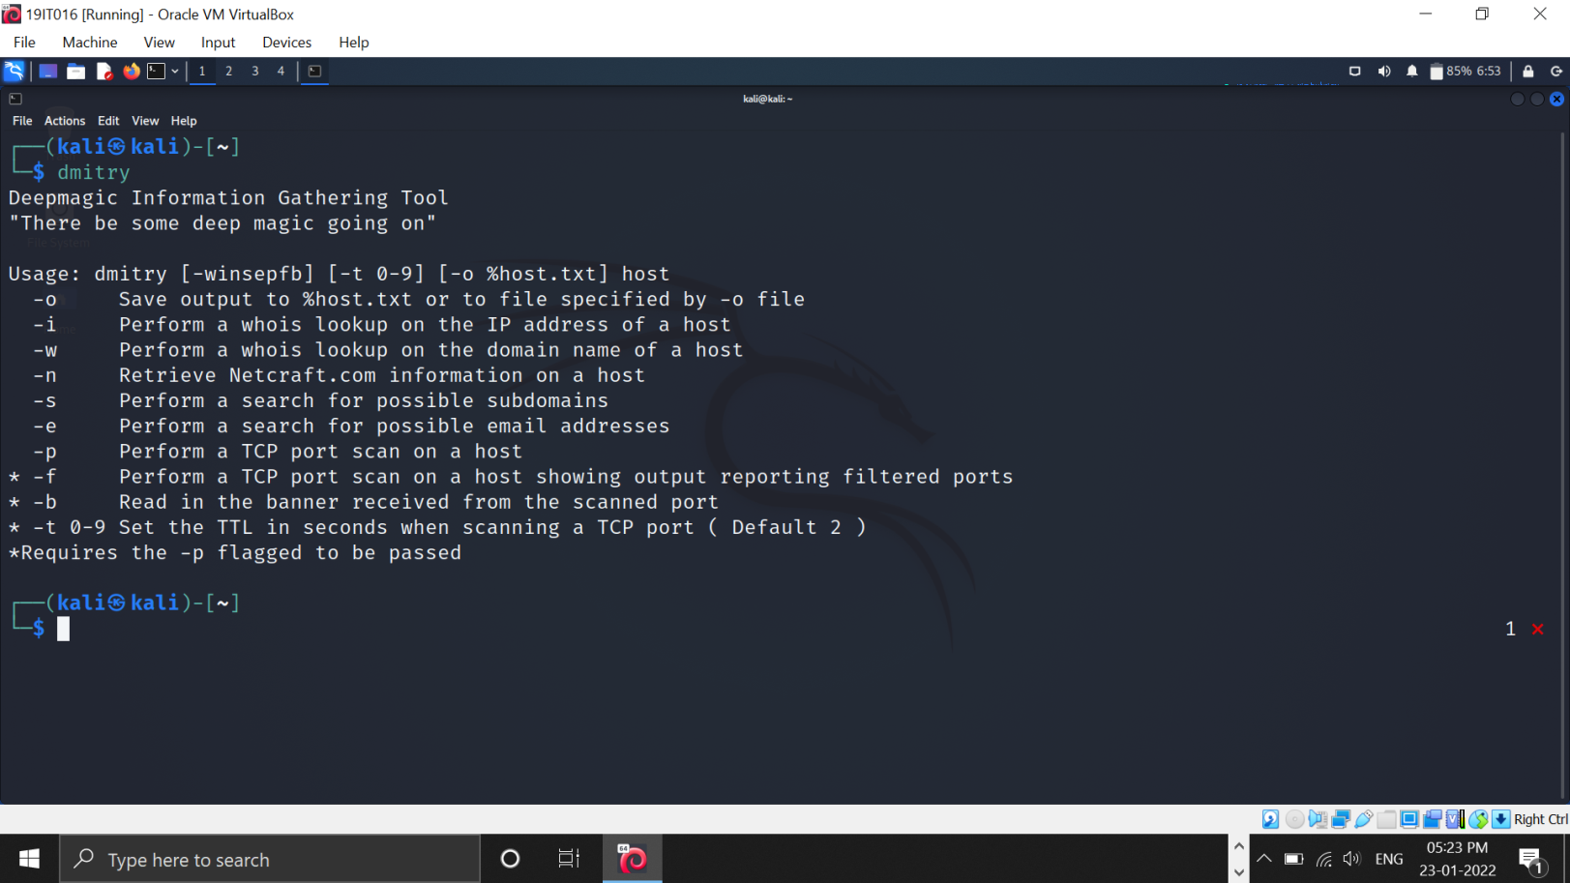

Open dmitry console in your kali os. Here we can see bunch of use cases of dmitry.

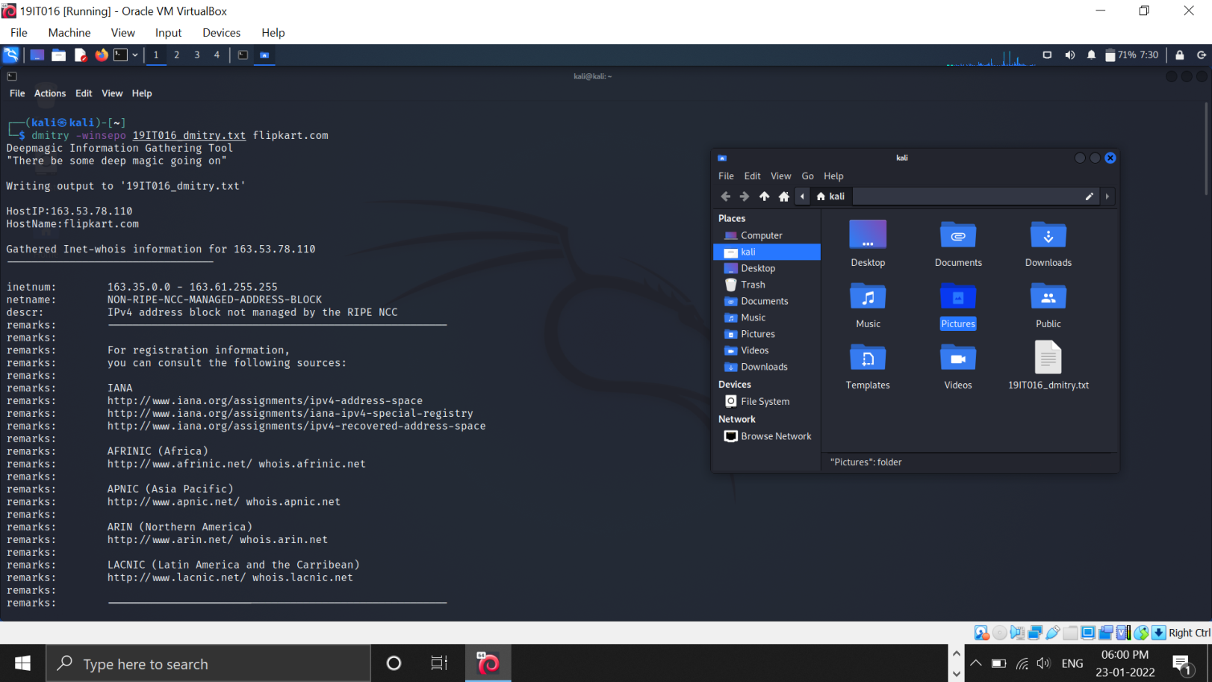

We are going to fetch some information of bWAPP website and will store that information in 19IT016_dmitry.txt file.

This is the file generated by dmitry command and we have stored all of the information in this file. These are some information related to bWAPP website route, source, creation date and origin.

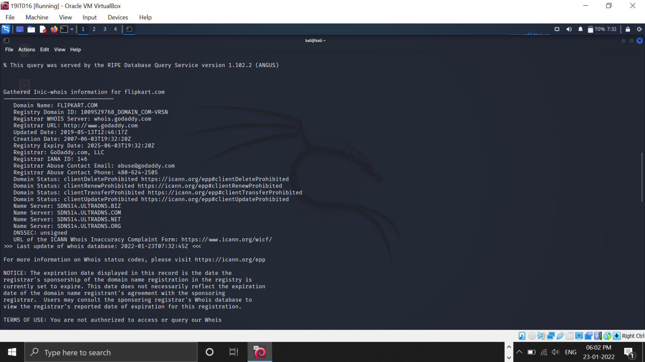

In these image there are information of domain name, id, website updation date, registrar's url

,name and many more things.

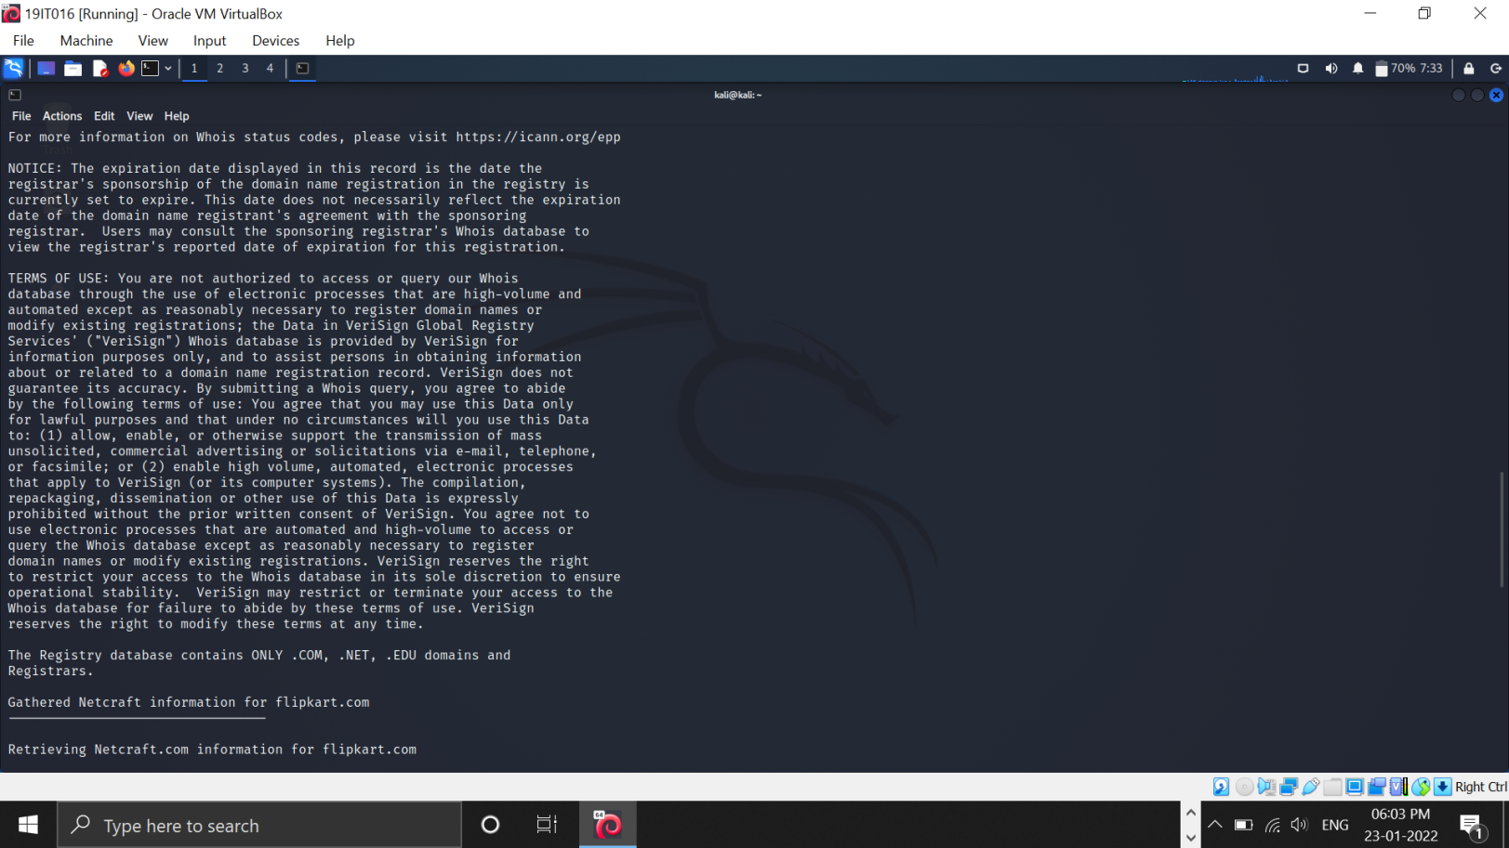

These are some terms and conditions related to website.

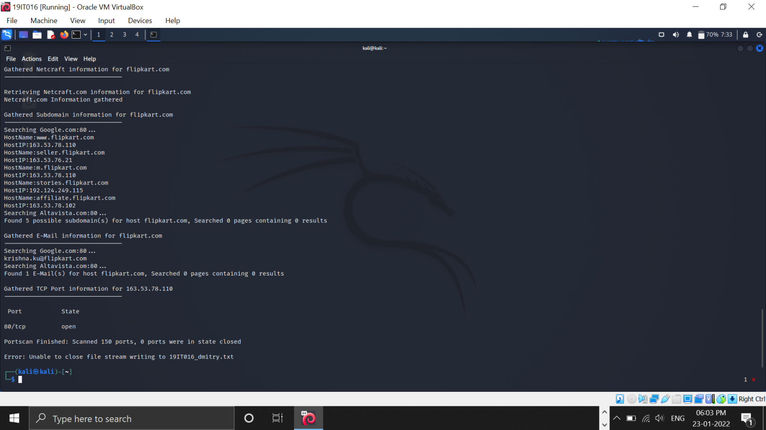

In this image we can see port information and email information of the website.

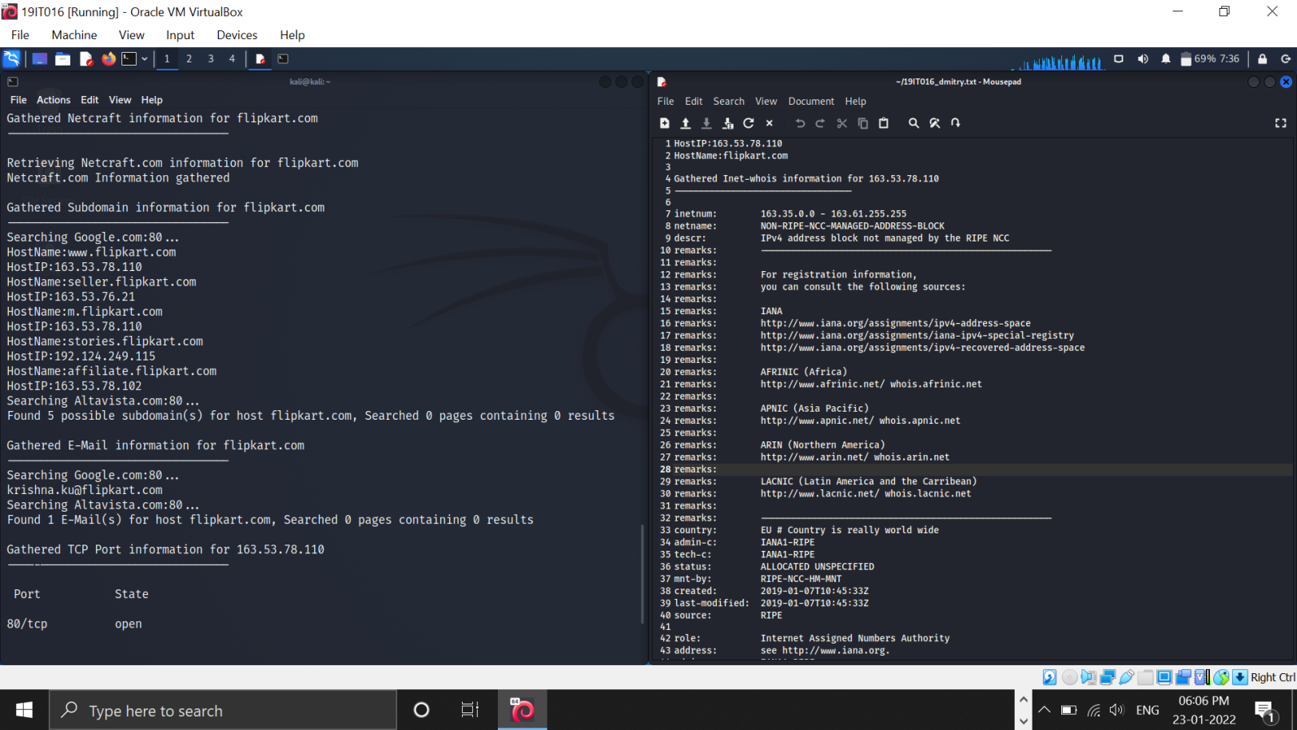

This is the content of the output file.

## Whatweb:

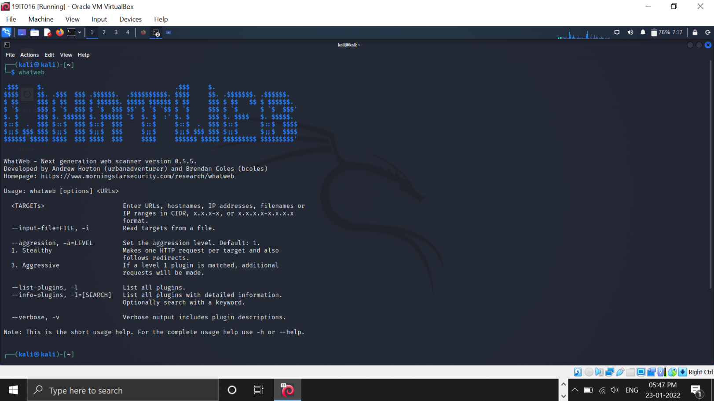

Open whatweb console. Here we can see some information about whatweb and it's uses.

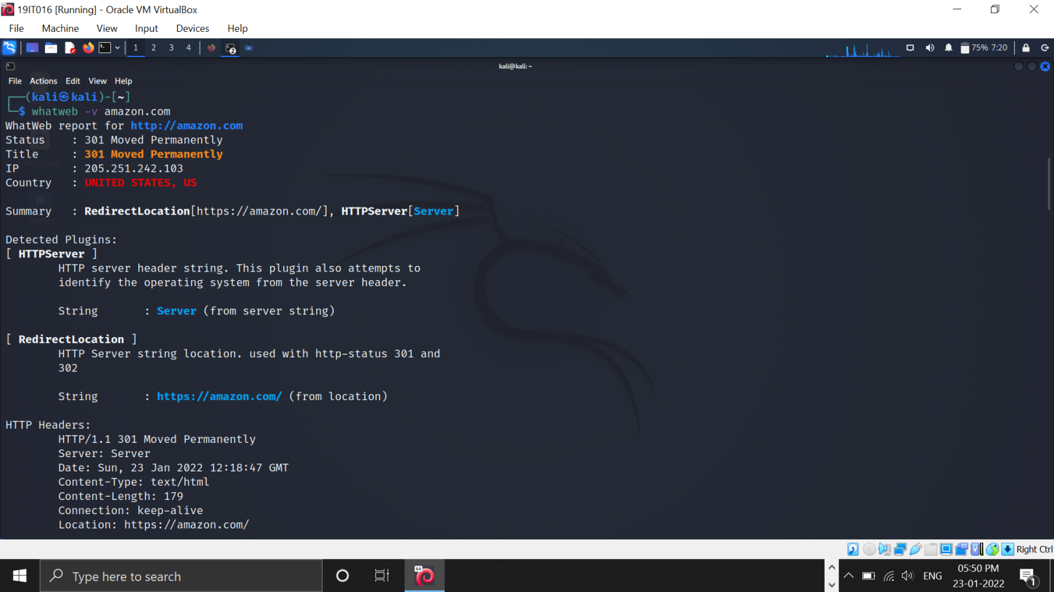

we can see the ip address,status and country of the website.And also we can see more information related to plugins and technologies used in the website.

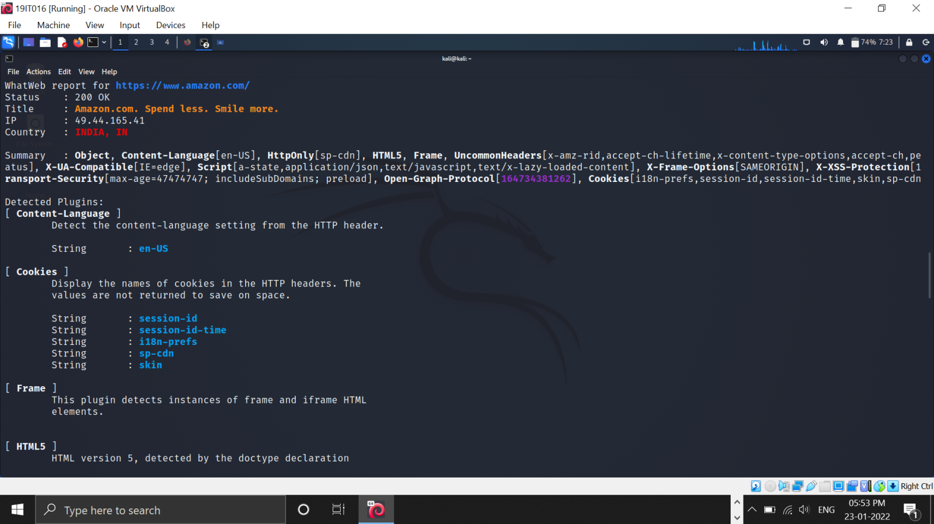

Here are some more information of technologies this website had used.

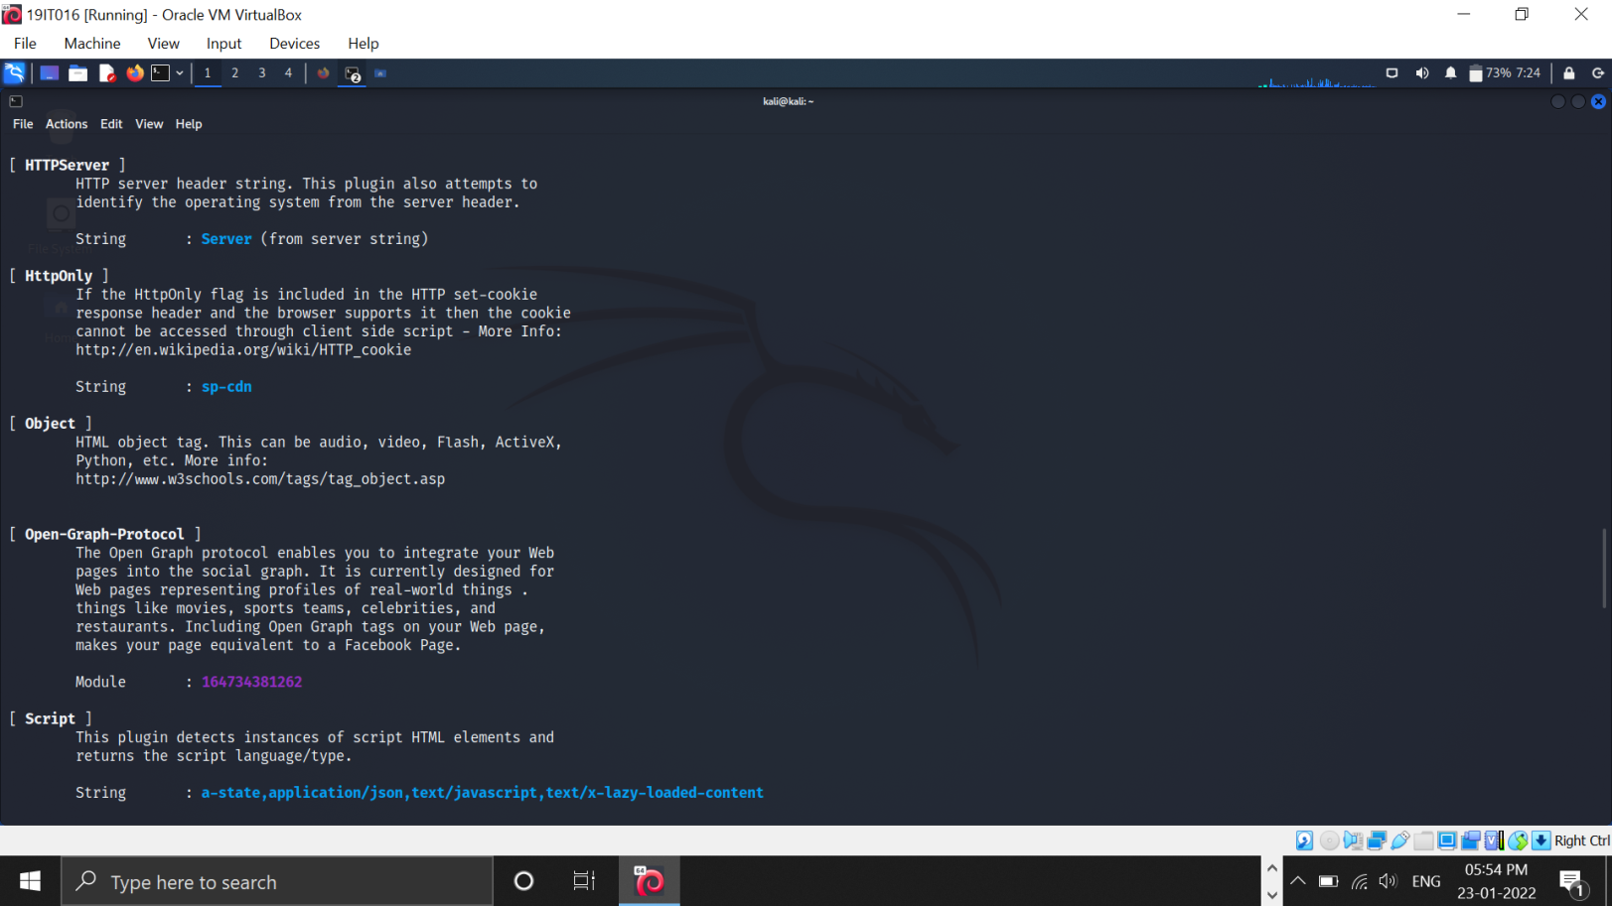

Here we can see which version of jquery is used. Which script is used.

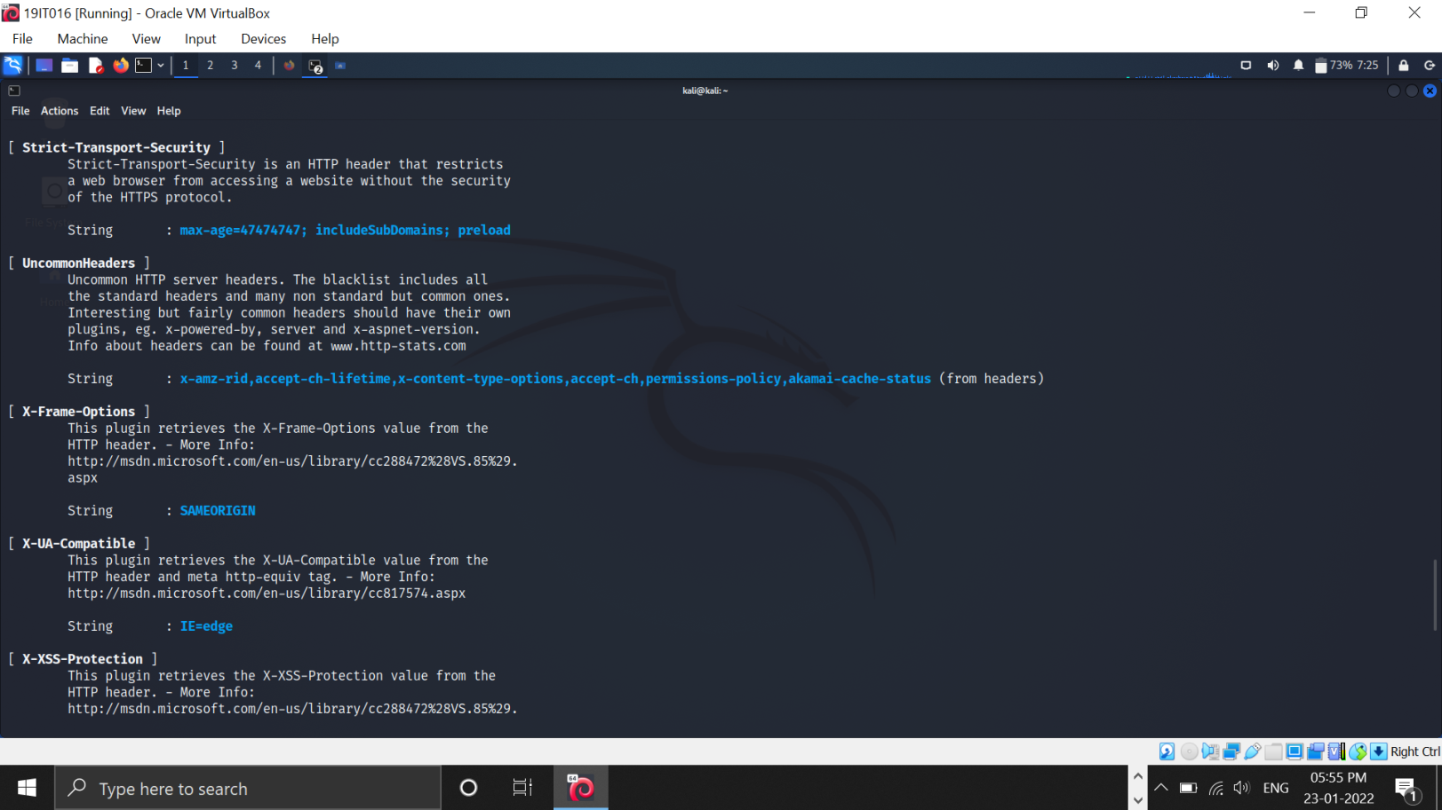

Here we can see what is strict-transport-security what is max string strength an all.

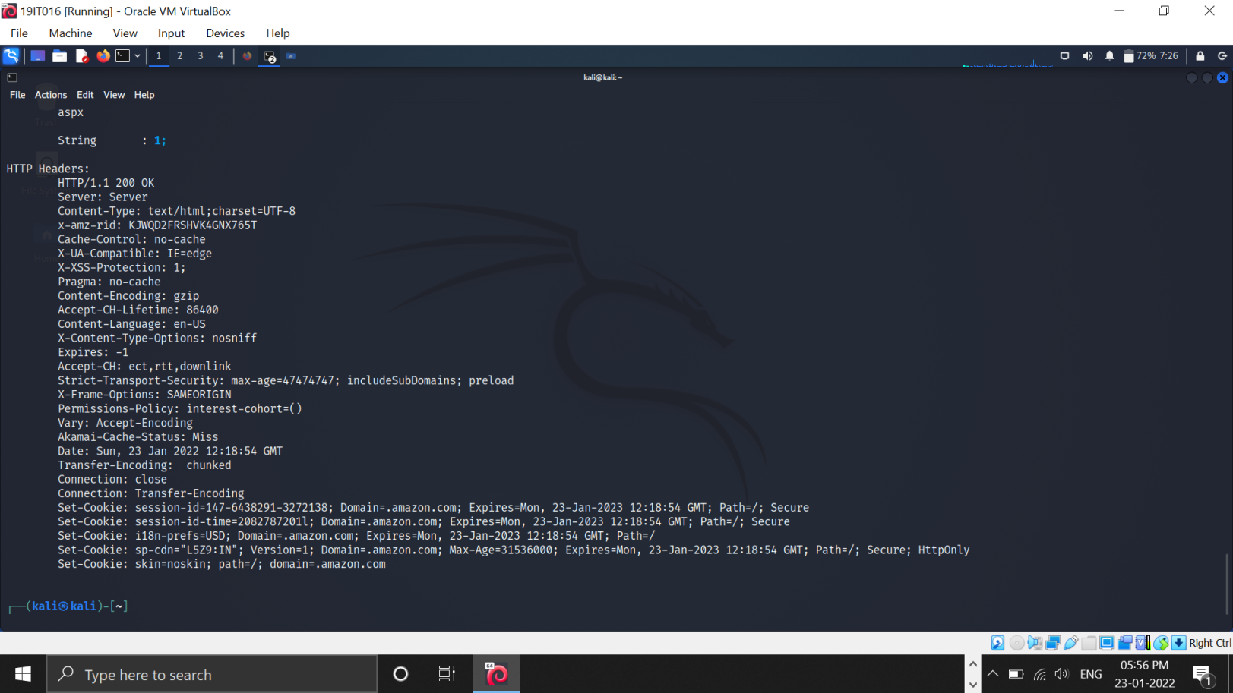

Some more information related to website technologies and plugins.

# LATEST APPLICATIONS:

With the use of Dmitry you can:

* Perform an Internet Number whois lookup.
* Retrieve possible uptime data, system and server data.
* Perform an E-Mail address search on a target host.

UA-tester is used to automatically check a given URL using a list of standard and non-standard User Agent strings provided by the user (1 per line). The results of these checks are then reported to the user for further manual analysis where required.

UA-tester is also used for:

* Initial version.
* Improved redirect handling.
* Released for limited Alpha testing
* Changed handling of default UA strings (no need for -d), added verbose output, single mode - s, handler for URL without HTTP://
* Added Android default UA string, altered -h to reflect changes to usage
* Expanded on user feedback to avoid confusion of results, added feedback to clarify results, expanded default user agent strings (categorized)

WhatWeb recognises web technologies including content management systems (CMS). WhatWeb has over 1800 plugins, each to recognise something different.

WhatWeb identifies:

* Platform
* CMS platform
* Type of Script
* Google Analystics
* Webserver Platform
* IP address, Country
* Plugins & their libraries used
* Server Headers, Cookies and a lot more

# LEARNING OUTCOME:

In this practical we have learned three useful kali linux tool which are used by many penetration testers and hackers for information gathering. First we have seen the what are the uses of dmitry, ua-tester and whatweb tool and then we used these tools on our kali os to gain practical knowledge. We learned that dmitry is used for information gathering, ua-tester is used for checking whether a website provides different pages for different user agents like for mobile, desktop bots etc. And whatweb is used to check which technologies website has used for creation of website.

# REFERENCES:

1. Dmitry : <https://www.youtube.com/watch?v=_zd3goGLM7Q>
2. UA Tester : <https://www.youtube.com/watch?v=WsTupi32ZYE> WhatWeb : <https://www.youtube.com/watch?v=Fx9sIgxcNwU>